
DEPARTMENT OF COMMERCE
BEST PRACTICES
Department of Commerce is giving much importance to nature. Nature is life and breathes of human being. In this context the department is practicing to present plants (samples) in each and every occasion to the dignitaries who attend departmental activities, commerce day and Consumers day celebrations etc.. Also gives messages on greenery and educate the students towards greenery.
Often involved the students in clean and green Swachha Bharath to inculcate the habit of cleanliness and greeneries among the students.
Every year in the third week of December the Department is conducting consumer awareness among the students by arranging awareness programmes, conducting essay writing, elocution competitions in three languages i.e. in Telugu, Urdu and English to the students to get awareness. Every year on24th December prizes were distributed to the winners in the competitions to motivate the students

PHOTOS:

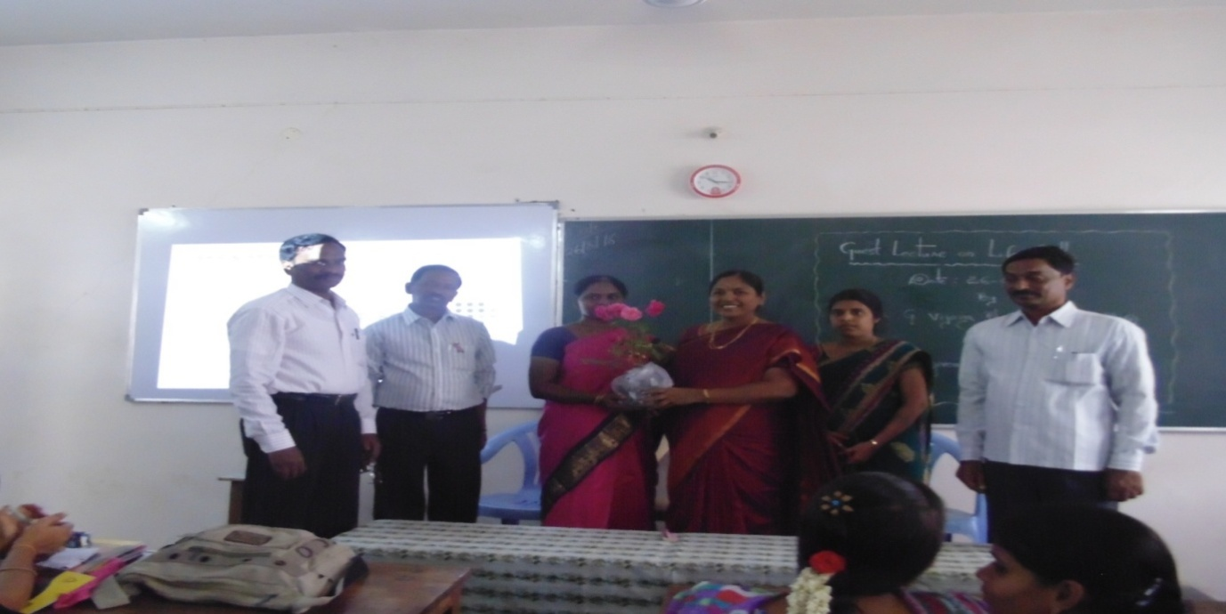
PRESENTATION OF PLANT BY Dr.P.Subba Lakshumma, Principal to the Resource Person Dr.G.Vijaya Bharathi Associate Professor Department of Commerce Yogi Vemana University, Kadapa on the Occassion of Guest Lecture on LIFE SKILLS.( DATE: 26-08-2016)

